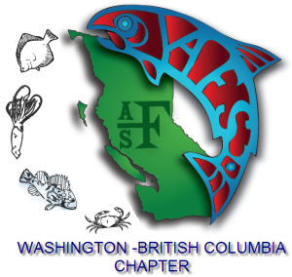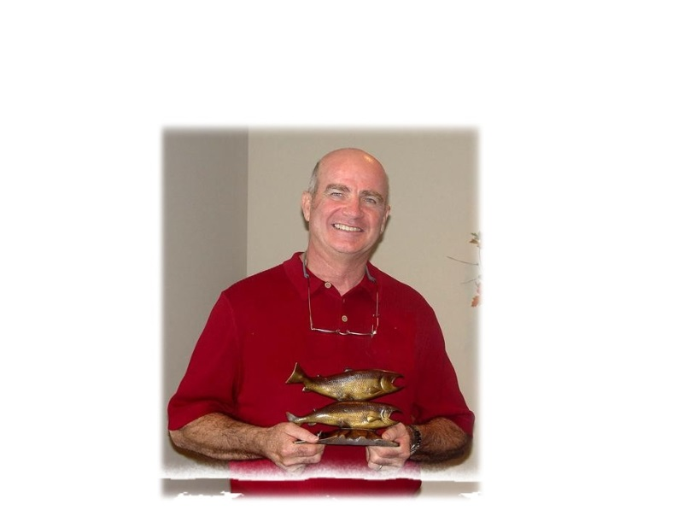

WAshington British Columbia CHapter of the AMerican Fisheries SOciety

*Quotes from colleagues*

Inside This Announcement

1 Endowment Brief History

1 The Scholarship

2 How To Apply

“Jeff was an inspiration and a fountain of knowledge for me.”

“His wildlife ethics were so far ahead of most of his peers”

“Jeff--he was without a doubt one of the most dedicated individuals I have ever known.”

# How to Apply

Provide a brief cover letter addressed to the C. Jeff Cederholm Scholarship Committee, fill out the attached application form, acquire two letters of recommendation and e-mail a merged pdf electronic version containing all elements to WA-BC AFS past president, Gabriel Temple, [gabrielt.temple.wabc.afs@gmail.com](mailto:gabrielt.temple.wabc.afs@gmail.com), or mail to WA-BC chapter American Fisheries Society, P.O. Box 9322, Spokane, WA 99209. E-mail submissions are preferred.

**Applications will be accepted through February 15th, 2020.**

The SEF will provide three equal value scholarships each school year, one each to an **undergraduate** student (pursuing a bachelor’s or associate’s degree), a student pursuing a **master’s degree**, and a student pursuing a **doctorate**.

The following scholarship criteria apply:

Scholarships are intended for defrayment of educational expenses such as tuition, student fees, lab fees, books, supplies, room and board.

Scholarships will be awarded to students pursuing degrees in fisheries, aquatic sciences, or related fields at an accredited college or university.

Master’s and PhD applicants must be Washington-British Columbia Chapter members at the time that their application is submitted.

Undergraduate applicants need not be Chapter members.

Scholarship for each given year will be equal amounts and will depend on the performance of the Endowment year to year. In 2019, **three $1000 scholarships will be awarded**.

# The Scholarship

Jeff Cederholm dedicated his career to conservation of salmon and aquatic species and their habitats. Jeff passed away in 2006 leaving a legacy of education, pioneering contributions to scientific literature and periodicals and instilling of passion for wild salmon conservation in many people for decades. After a successful American Fisheries Society Meeting hosted by the WA-BC Chapter in Seattle 2011, the Chapter resolved in 2013 to apply raised funds and subsequent contributions to the endowment to create a permanent source of financial support for educational expenses. The Scholarship is administered by the WA-BC Chapter Endowment Committee.

# Endowment Brief History

C. Jeff Cederholm

Scholarship Endowment Fund

**Student Award Scholarship Application Process**