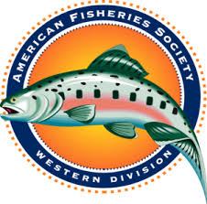
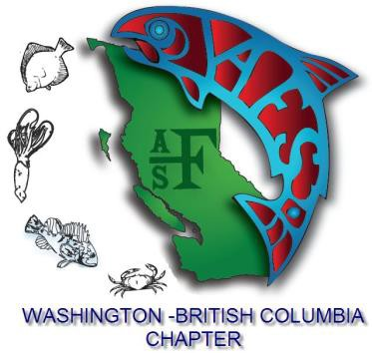
AMERICAN FISHERIES SOCIETY

2020 Annual Meeting of the

Western Division

hosted by

the WA-BC Chapter
April 12 - 16, 2020
Pinnacle Harbourfront Hotel, Vancouver, BC
CALL FOR CONTINUING EDUCATION COURSE PROPOSALS

Looking to present a deeper dive into a particular fisheries subject? The Western Division and Washington-British Columbia Chapter of the American Fisheries Society invite you to submit your continuing education course proposals for the 2020 Annual General Meeting to be held in Vancouver, British Columbia, Canada April 12 - 16.

Course organizers are encouraged to submit proposals, and recruit attendees. Workshops can be full (6-8 hours) or half (2-3 hour) day and will be held on Thursday April 16th, 2020.

FORMAT FOR CONTINUING EDUCATION PROPOSALS - When submitting your proposal, please include the following:

Workshop title: Be brief but descriptive.
Organizer(s) name(s), contact info: Provide first and last name, affiliation, telephone number, and e-mail address of
organizer.
Description: Submit a brief (<300 word) abstract that describes your proposed course. Deadline for course submittals is January 10th, 2020.

Technical requirements: For example, AV requirements (including if you need power cords for laptops) and room setup information. Any specialized equipment must be provided by the workshop leader. We will be providing rooms (arranged how you wish) and AV equipment (mic, projector, display, power cords), but other specialized equipment must be provided by the workshop leader.

Course Fee: Workshop leaders can set the price of their workshop and all proceeds will go to the workshop leader. Fees will be paid by attendees during registration, and instructors will be reimbursed after the course has been completed. All fees will be in USD.

Minimum and maximum attendance: It is up to the workshop leader to set the minimum number of attendees to make the event viable.

Email Sam Wilson (swilson471@gmail.com) your course proposals or contact for additional information.

