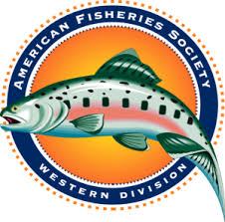
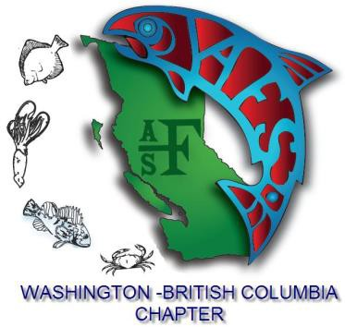
AMERICAN FISHERIES SOCIETY

2020 Annual Meeting of the

Western Division

hosted by

the WA-BC Chapter
April 12 - 16, 2020
Pinnacle Harbourfront Hotel, Vancouver, BC
CALL FOR PAPERS

The Western Division and Washington-British Columbia Chapter of the American Fisheries Society invite you to submit your presentation and poster abstracts for the 2020 Annual General Meeting to be held in Vancouver, British Columbia, Canada April 12 - 16. The theme this year will be “Crossing Boundaries and Navigating Intersections”.

Those who wish to present in symposia, contributed papers or poster sessions are required to submit abstracts by February 12, 2020.

Students wishing to compete for the Best Student Paper Award MUST select “Student Symposium” when submitting abstracts. Note that student oral presentations outside this symposium will not be eligible for the award. To compete for the Best Student Poster Award, students must select “Poster Session” and check the box “Yes” when asked if you wish to compete for the award.

We have organized a variety of exciting symposia for the meeting! (https://wa-bc.fisheries.org/2020-meeting/program/symposia) Abstracts to be considered for the symposia, contributed papers and poster sessions may be submitted at http://wa-bc.fisheries.org/2020-meeting/abstract-submission/.

Confirmation of acceptance or refusal of abstracts will be communicated by February 21, 2020.

Program Committee Contacts:

Program Co-Chairs: Todd Pearsons tpearso@gcpud.org (509) 859 - 2862
and
Paul Spruell pspruell@ewu.edu (509) 359 - 7006

Contributed Sessions: Alf Haukenes ahaukenes@gmail.com (509) 545 – 2013

Posters Chair: Laura Burckhardt laura.burckhardt@wyo.gov (307) 250 – 1213

AFS does not waive registration fees for presenters at symposia or contributed papers sessions, or workshops. Registration forms will be available on the meeting website (http://wa-bc.fisheries.org/2020-meeting/registration/) in January 2020. Register early for cost savings!

